Fall 2010
Volume 2, Issue 1
University of Washington Psychology Department
Box 351525, Seattle, WA 98195 206-616-5768 or go123@u.washington.edu
Watching children's emotional development
Project 1, 2, 3, Go!
In this issue:
- Emotions
pg 1
- Famous Quotes
pg 1
- The Jumping Spider
pg 2
- Psychology Spotlights
pg 2-3
- Congratulations!
pg 3
- Fun/Free Winter Activities
pg 4

An important step in young children's development is how they learn to manage their feelings. You've probably noticed that as children grow, they have fewer crying spells when they've learned how to better communicate their feelings.
Over the past few years, we have engaged children in activities that allow us to observe how their responses to different emotional situations change as they grow.
During children's visits, they are shown a fake spider. Early on, some children felt so timid they sometimes cried. Now they are
more likely to coach themselves to stay calm or ask questions. Other children reached for the spider before even thinking about it. Now, they are more likely to pause and think. In other activities they have shown more patience, less frustration, and better recognition of facial expressions, all signs of better emotion management. One of the great things about watching children grow during the preschool years is that you really can see them "Stop and Think!"—an important skill for managing feelings.


Famous Quotes from Project 1, 2, 3, GO!
To the question on our survey, "Reports accidents to the appropriate persons," one mother responded, "Very often—it's called 'tattle-tale-ing!'

Page 2
Watch out for the Jumping Spider!
Our undergraduate research assistants are valuable team members for many reasons including the funny and endearing stories they share with us about their research experience. We've asked them to share some of their favorite memories on the project and the story about Katie and the jumping spider seems to be perfect as we approach Halloween. We hope you enjoy her story as much as we did!
“One time, as the child tester, I took one for the team. It was time for ‘jumping spider,’ and I was working with a timid boy. I knew that this task would not go over well if his hand came within an inch of the box. After asking me several times, ‘Is it real?’ he reached inside the box, and I made the spider jump. The boy flew up in his seat and started crying immediately.

To soothe him, I showed him that it was I who had maneuvered the spider. He looked at me and asked, ‘You did it?’ I said yes and offered him the spider and showed him how to make it jump at me. The first time he did it, he let out a giggle as I pretended to get very frightened and jumped back in my chair. By the third attempt, he was happy again and made the spider jump at me once more. Upon doing that, I jumped back in my chair so hard that I took it with me and flipped over backwards into the boards that rest against the toy shelf. The boards bent in half and some toys toppled onto my head. Embarrassing as it was for me, the boy found this extremely entertaining and for the rest of the activities, he would not stop asking me to do it again!”

Psychology Spotlight: Violeta
I've always loved interacting with kids, and when I first heard about Project 1, 2, 3, Go! I knew it was the place I had to be! I graduated last spring with a bachelor’s degree in psychology, but am continuing my work on the project. Being a team member here for the past few years has really taught me a lot about people and myself. My interactions with the kids and moms on the project have all been great lessons for my future career and for life! It has been so much fun being able to work with so many awesome families, many of whom I have worked with for more than one visit! Seeing the changes in children over a nine month period is incredible and some kids seem to come back completely different!


Page 3

Psychology Spotlight Continued: Tammy (with a large fish!)

Tammy is currently a sophomore at the UW and joined Project 1, 2, 3, Go! last spring.
" I love everything about 1, 2, 3, Go!, especially working as a team with the children. It brings me so much joy to see and share the enthusiasm of the children in their accomplishments. They have grown so much and make great team members by helping out with the tasks and working so hard to complete the activities. They are just such helpful hands and it's great to see them work so hard and come back for their follow up visits! It's fun to see how excited the children are to do the tasks and to know that they love them as much as we do! I also love seeing new and familiar faces on the project. When families walk through the door and they are smiling, it makes me even more excited and happy to be on the team! "
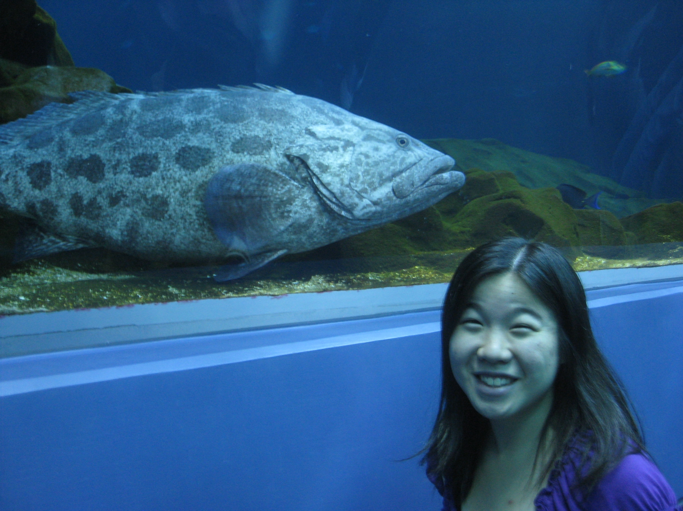

Tammy also helps out with data entry and makes follow up phone calls to teachers and families.
For activities outside the project, Tammy likes jogging and taking walks on the Burke Gilman trail. She also likes baking and swimming. Thanks for all your hard work Tammy!



Congratulations!

Some families recently completed their 4th visit! We thank them wholeheartedly for staying with the project through all the visits and for enriching our research and lives by letting us get to know them.
We look forward to staying in touch so we can continue to share the results of our research and much more! We also hope to check back in with you in a couple of years to see how your children have grown and developed!
Remember to check out our website if you haven’t visited it yet: http://depts.washington.edu/cfnkw/123gohome.html We’ll update it so you’ll have the latest information on our progress here at Project 1, 2, 3, Go!



Fun, Free Activities to Do Indoors Over the Winter!

The Museum of Flight
Free - first Thursday of every month 5-9pm
9404 East Marginal Way South
Seattle, WA 98108-4097
(206) 764-5720
Imagine Children’s Museum
Free - third Friday of every month 5:30-9pm.
1502 Wall Street
Everett, Washington 98201
(425) 258-1006
Pajama Story Times
Mondays – September 13 to December 6-7pm
Renton Libraries
Wear you pajamas to the library, bring a stuffed animal enjoy stories, songs, and finger puppets!
(425) 226-6043 or (425) 277-1831
Malls with Kid-Friendly Indoor Play Areas

Bellevue Square (Bellevue)
Crossroads Bellevue (Bellevue)

REI (Seattle)
IKEA (Kent)
Supermall (Auburn)

Westfield Southcenter (Tukwila)
Lake Forest Park Towne Center (Bothell)
Alderwood (Lynnwood)

